# Configuration Of Aparavi Agent / Collector

This article assumes that you have already successfully installed an Aparavi Aggregator and a Collector, or an Agent and that the corresponding client is online.

You can find a full documentation of the entire installation process here:

<https://support.aparavi.com>

# Definition of the crendentials in Aparavi Presentation Layer for the use with Microsoft Azure Storage Account

1. Log in to the Aparavi Presentation Layer
2. Check the status of the Agent / Collector and make sure that it is onlineEin Bild, das Text enthält.

   Automatisch generierte Beschreibung
3. Chose your client and select “Policies”. Then, chose “Include Path”.Ein Bild, das Text enthält.

   Automatisch generierte Beschreibung
4. The correct path definitions follow this rule: \\<NAME OF THE STORAGE ACCOUNT>.file.core.windows.net\<NAME OF THE FILE SHARE>, example: \\aparavistorage.file.core.windows.net\aparavifileshare
5. After this step, set the correct credentials for the storage account.
6. Switch to “Credentials” and click the button “Add Credentials”.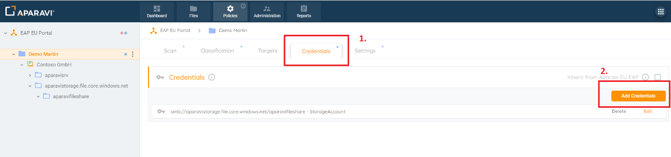
7. The “User” corresponds to the name of the Azure Storage Account. The “Password” requires the “Key” of the Azure Storage Account which can be find in the Azure Portal.

Ein Bild, das Text enthält.

Now, it is possible to migrate your test data to the Azure Storage Account and connect the data with the Aparavi Platform.

You can use the Microsoft Storage Account Explorer for data migration. [Azure Storage Explorer – cloud storage management | Microsoft Azure](https://azure.microsoft.com/en-us/features/storage-explorer/#overview)